Microsoft Access 2010 Chapter 1 – Lab Test A
Creating an Electronic Accessories Database

Purpose: To demonstrate the ability to create a database, create queries, a form, and create a report.

Problem: An electronics store wants to keep track of its sales representatives for its various outlets. The database it will use consists of two tables. The Outlets table contains data on the particular outlet store. The Sales Rep table contains pertinent data about the electronics store’s sales representatives.

Instructions: The structure for the Outlets table is shown in Table A1A– 1 and the data is shown in Table A1A– 2. The structure for the Sales Rep table is shown in Table A1A– 3 and the data is shown in Table A1A– 4.

1. Create a new database to store the two tables related to the electronics store. Call the database, HaveMore Electronics.
2. Create the sales representatives table using the structure shown in Table A1A– 1. Make the Sales Rep ID the primary key. Use the name, Sales Rep, for the table.
3. Add the data shown in Table A1A– 2 to the Sales Rep table.
4. Save the Sales Rep table and print it.
5. Create the outlets table using the structure shown in Table A1A– 3. Make the Outlet ID the primary key. Use the name, Outlets, for the table.
6. Add the data shown in Table A1A– 4.
7. Save the Outlets table and print it.
8. Create a query for the Sales Rep table. Include the Sales Rep ID, Name, Outlet ID, Quota, and YTD Sales in the query. Save the query as Sales Rep Query.
9. Open the Sales Rep Query and add a criterion to limit retrieval to those sales representatives located in outlet HME 11. Save the query as Sales Rep – HME 11 Query.
10. Create a simple form for the Sales Rep table. Use the name, Sales Rep Form, for the form.
11. Create the report shown in Figure A1A–1 for the Sales Rep table. Add totals for the Quota and YTD Sales.
12. Change the database properties, as specified by your instructor. Submit the database in the format specified by your instructor.

Structure of the Sales Rep table
Field Name | Data Type | Field Size | Primary Key? | Description
Sales Rep ID | Text | 3 | Yes | Sales Representative ID (Primary Key)
Full Name | Text | 25
Gender | Text | 1 |  | Gender (M or F)
Age | Number
Hire Date | Date/Time
Outlet ID | Text | 6 |  | Outlet ID
Quota | Currency
YTD Sales | Currency |  |  | Year to date sales amount

Table A1A – 1

Data for the Sales Rep table
Sales Rep ID | Name | Gender | Age | Hire Date | Store ID | Quota | YTD Sales
321 | Moeller, Pierre | M | 24 | 3/12/2001 | HME 11 | 3,656,640 | 3,336,300
101 | Battistini, Jorge | M | 26 | 7/2/2001 | HME 15 | 3,371,092 | 1,960,932
205 | Lambert, Paul | M | 35 | 3/16/2002 | HME 11 | 1,768,442 | 1,525,237
613 | Brunell, Candace | F | 36 | 6/1/2002 | HME 17 | 3,000,264 | 2,078,386
475 | Dunn, Alan | M | 39 | 6/6/2002 | HME 26 | 1,652,836 | 1,432,701
125 | Lyon, Jody | F | 27 | 8/3/2002 | HME 15 | 2,280,900 | 1,548,311
324 | Bulger, Gloria | F | 25 | 12/23/2002 | HME 15 | 2,651,270 | 2,451,454
140 | Lopez, Maria | F | 25 | 6/3/2004 | HME 17 | 1,837,213 | 1,563,140
285 | Dillig, Henry | M | 42 | 11/21/2006 | HME 11 | 3,899,402 | 1,916,753
512 | Kahn, Ramesh | M | 44 | 4/6/2007 | HME 26 | 3,426,535 | 3,292,270
678 | Chiu, Leslie | F | 36 | 7/15/2007 | HME 26 | 3,218,514 | 2,514,181
287 | Wochos, Lisa | F | 30 | 10/21/2007 | HME 15 | 2,648,883 | 2,188,106
465 | Cataldo, Lydia | F | 25 | 11/15/2007 | HME 11 | 3,668,028 | 2,846,910

Table A1A – 2

Structure of the Outlets table
Field Name | Data Type | Field Size | Primary Key? | Description
Outlet ID | Text | 6 | Yes | Outlet ID (Primary Key)
Address | Text | 25 |  | Outlet Address
City | Text | 20
State | Text | 2
Zip | Text | 5

Table A1A – 3

Data for the Outlets table
Outlet ID | Address | City | State | Zip
HME 11 | 1298 Western Court | Bedlam | CA | 34896
HME 15 | 25 Parkington Palace | Southtown | CA | 39746
HME 17 | 1212 Mocking Bird | Ambervson | CA | 38957
HME 26 | 774 Oakland | Parkville | CA | 38974

Table A1A – 4

HME 11 | 1298 Western Court | Bedlam | CA | 34896
HME 15 | 25 Parkington Palace | Southtown | CA | 39746
HME 17 | 1212 Mocking Bird | Ambervson | CA | 38957
HME 26 | 774 Oakland | Parkville | CA | 38974

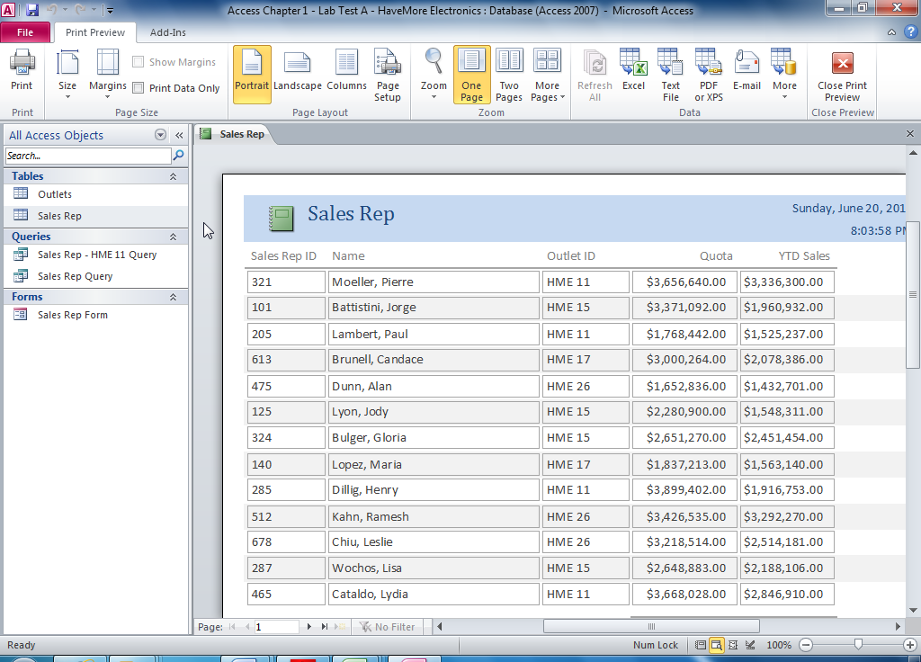

Figure A1A – 1

