Microsoft Access 2010 Chapter 1 – Lab Test B
Creating a Database for a Pet Grooming Salon

Purpose: To demonstrate the ability to create a database with multiple tables, produce queries, forms and reports.

Problem: Fritz’s Grooming wants to create a database for keeping track of their clients as well as the groomers who are assigned to them. The groomers have different base rates given their years of experience and training. The database will have two tables. The Pet table will keep track of the pet clients, and the Groomer table will keep track of the groomer information.

Instructions: The structure for the Pet table is shown in Tables A1B– 1. The structure for the Groomer table is shown in Tables A1B– 2. The data for the Pet table and the Groomer table can be found in the data files for this lab test. See your instructor for instructions on accessing the data files for this lab test.

1. Create a new database to store the tables related to the not-for-profit organization data. Call the database Fritz’s Grooming.
2. Create the Pet table using the structure shown in Table A1B – 1. Make the Pet ID the primary key. Use the name, Pet, for the table.
3. Import the data for the Pet table from the data file, Access Chapter 1 – Lab Test B – Pets.xlsx.
4. Print the table.
5. Create the Groomer table using the structure shown in Table A1B – 2. Make the Groomer ID an index with duplicates. Use the name, Groomer, for the table.
6. Import the data for the Groomer table from the data file, Access Chapter 1 – Lab Test B – Groomers.xlsx.
7. Print the table.
8. Create a query for the Pet table. Include the Pet ID, Owner Name, Dog Name, Breed, and Groomer ID in the query. Save the query as Pet Query.
9. Open the Pet Query and add a criterion to limit retrieval to the groomer whose id is 147893. Save the query as Pet – Groomer 147893 Query.
10. Create a simple form for the Groomer table. Use the name, Groomer Form, for the form.
11. Create the report shown in Figure A1A–1 for the Pet table. Add a count for Pet ID.
12. Change the database properties, as specified by your instructor. Submit the database in the format specified by your instructor.

Structure of the Pet table
Field Name | Data Type | Field Size | Primary Key? | Description
Pet ID | Text | 4 | Yes | Pet ID (primary key)
Owner Name | Text | 25
Dog Name | Text | 20
Gender | Text | 1 |  | Gender (M or F)
Age | Number
Breed | Text | 25
Groomer ID | Text | 6
Table A1B – 1

Structure of the Groomer table
Field Name | Data Type | Field Size | Primary Key? | Description
Groomer ID | Text | 6 | Yes | Groomer ID (Primary Key)
Full Name | Text | 30
Station Num | Text | 1 |  | Preferred working station number
Base Rate | Currency |  |  | Base rate for grooming
Table A1B –2

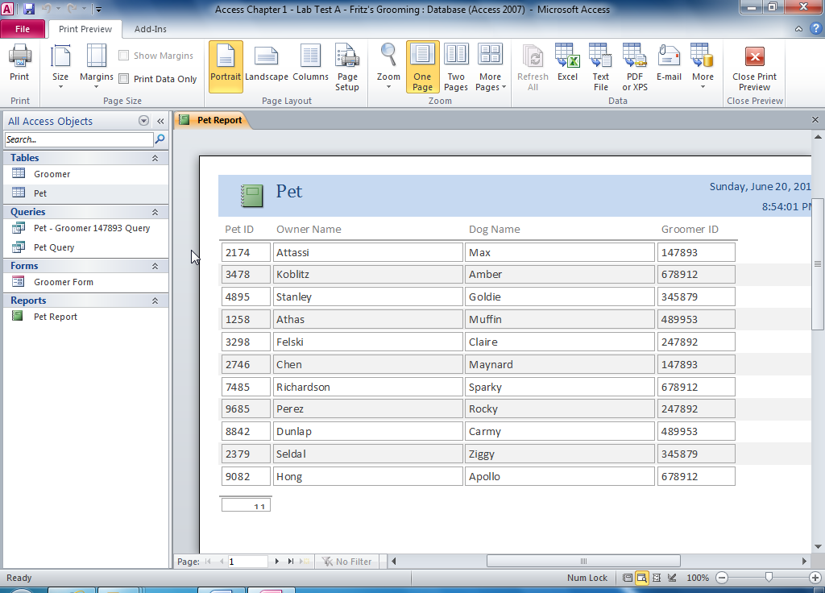

Figure A1B – 1

