Microsoft Excel 2010 Chapter 1 – Lab Test A

Creating an Analysis Worksheet

Purpose: To demonstrate the ability to build a worksheet, format a worksheet, embed a column chart, print a worksheet, and save a workbook.

Problem: You are working for a travel agency. You want to track and compare the prices for four of your customers favorite destinations using the popular 5-Day packages. Your worksheet will show the packages in the first column and the package prices for the four destinations in the other columns, as shown in Table E1A-1.

Instructions: Perform the tasks below to design and create the Vacation Package Analysis Workbook. Use the data provided in Table E1A-1.
- Using the data in Table E1A-1, create the worksheet shown in Figure E1A-1.
- Use the Solstice Theme.
3. Use AutoSum to create the total revenue for each of the four vacation spots and the totals for each of the four vacation packages.
4. Format the worksheet title, VACATION PACKAGE ANALYSIS, as Heading 1 style, and centered across columns A through F.
5. Using AutoFormat on the Format menu, format the range A2:F8 using the Heading 3 style. Use appropriate styles (comma style and currency style) to format the remaining cells so the worksheet displays as shown in Figure E1A-1.
6. Use the Chart Wizard button to add the 3-D Clustered column chart shown on the worksheet in Figure E1A-1. Apply the Style 20 chart style to the chart.
7. Name the worksheet Vacation. Color the tab blue.
8. Edit the document properties according to the instructions from your instructor. Save the workbook on your disk using the file name, Yourname - Excel Chapter 1 - Lab Test A, where Yourname is your own last name.
9. Print the worksheet.
10. Change the amount for the All Inclusive package for Alaska to 6,538. Decrease the amount for Hotel Only in Cancun to 1,787 and the amount for Tours Plus in Hawaii to 3,208. The vacation spot totals will be: Hawaii – $13,241.00, Aruba – $11,248.00, Cancun – $14,450.00, and Alaska – $20,563.00. Print the worksheet containing the new values. Close the workbook without saving the changes.

VACATION PACKAGE ANALYSIS
5-Day Packages | Hawaii | Aruba | Cancun | Alaska | Totals
All Inclusive | $8,084.00 | $ 6,489.00 | $ 7,251.00 | $ 5,254.00
Tours Plus | 3,589.00 | 3,125.00 | 4,683.00 | 8,561.00
Hotel Only | 1,250.00 | 975.00 | 2,153.00 | 3,515.00
Cruise | 699.00 | 659.00 | 729.00 | 1,949.00
Totals

Table E1A - 1

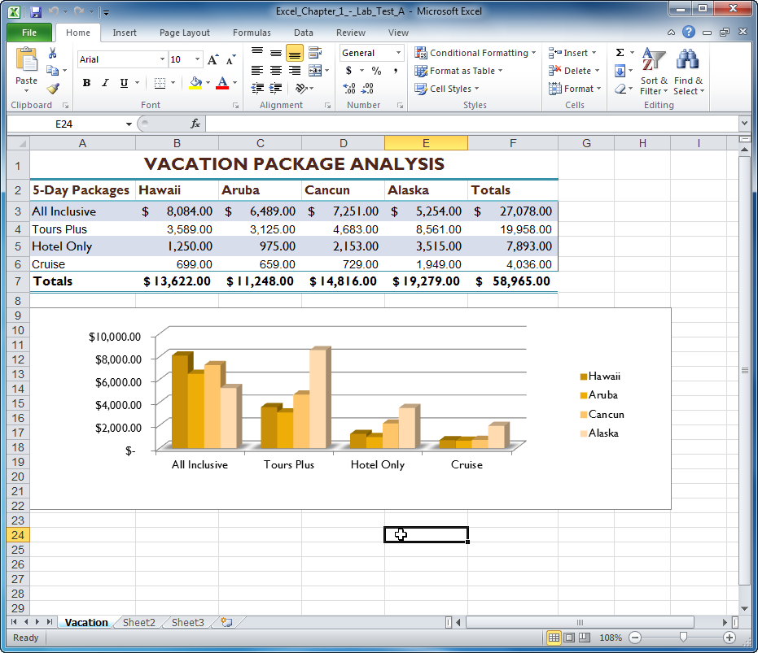

Figure E1A - 1

