Microsoft Excel 2010 Chapter 1 – Lab Test B
Creating a Sales Comparison Worksheet

Purpose: To demonstrate the ability to plan and build a worksheet.

Problem: You work for Calipso Crystals head office. You are tasked with comparing the monthly sales for the main items sold in its four stores. You have gathered the information listed in Table E1B-1 below. Create a worksheet to compare monthly sales for four stores.

Instructions: Design and create the Cost Comparison Sheet. Use the data provided in Table E1B-1.

- Use the techniques learned in Chapter 1 to create a worksheet that includes the data provided in Table E1B-1.
- Change the style to Verve.
- Format the worksheet title, Calipso Crystals, as Heading 1 style, and centered across columns A through E.
- Use cell styles to format cell range A2:E8 similar to that found in Figure E1B-1 . Use the following styles: Cells A1:E1 - Heading style. Cells A3:A7 - cell style 20% Accent 2. Cells - A2:E2 in Heading 3 style. Cells A8:E8 - total style.
- Include a 3D Cylinder column chart that compares monthly sales values. Apply the Style 22 chart style to the chart.
- Name the worksheet Monthly Sales. Color the tab Purble, Accent 4, lighter 40%.
- Edit the document properties according to the instructions from your instructor. Save the workbook on your disk using the file name, Yourname - Excel Chapter 1 - Lab Test B, where Yourname is your own last name.
- Print the worksheet with the chart.
- Change the monthly sales amount of ear rings in Miami to 575, the box sets of Tampa to 2,450 , and the necklaces of Daytona to 967. Print the worksheet with the new values. Close the workbook and don’t save changes.

Calipso Crystals Monthly Sales
Inventory | Daytona | Tampa | Orlando | Miami
Bracelets | $600.00 | $629.00 | $675.00 | $699.00
Ear Rings | $390.00 | $275.00 | $420.00 | $325.00
Necklaces | $1,200.00 | $950.00 | $1,500.00 | $1,125.00
Box Sets | $990.00 | $1,200.00 | $1,250.00 | $1,120.00
Wind Chimes | $315.00 | $395.00 | $410.00 | $365.00
Grand totals

Table E1B-1

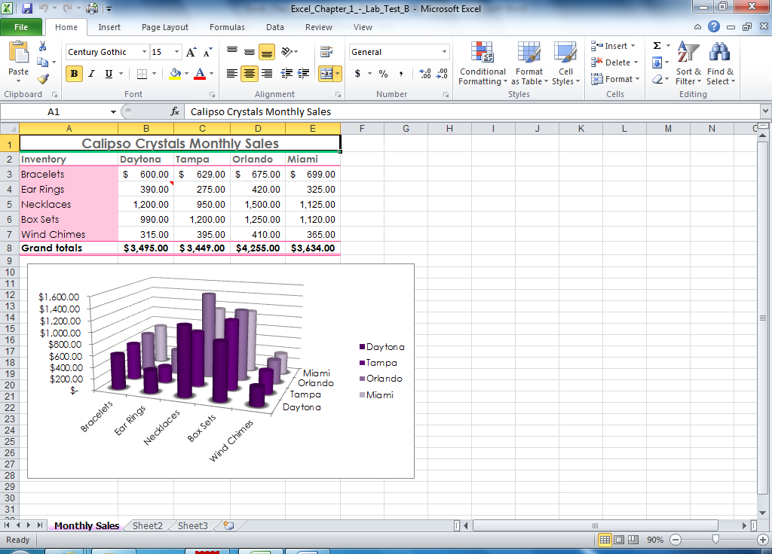

Figure E1B-1

