Microsoft PowerPoint 2010 Chapter 1 – Lab Test A
Building a Presentation

Purpose: To demonstrate the ability to design a presentation, apply a theme, insert clip art, and save a presentation.

Problem: You have been asked to create a presentation for an upcoming conference. You will be speaking about what makes a successful Web site. You will be using the notes found in Figure PP1A-1 to create your presentation. Your slides will be similar to those found in Figure PP1A-2.

Instructions: Perform the following tasks.

1. Create a new presentation using the Hardcover document theme.
2. Using the typed notes illustrated in Figure PP1A-1, create the title slide shown in Figure PP1A-2a. Italicize the title, and increase the font size to 48 point. Change the font size of the of the subtitle text to 36 point. Change the font color of the title text to Yellow (fourth color in the Standard Colors row) and of the subtitle text to Purple (tenth color in the Standard Colors row).
3. Using the typed notes in Figure PP1A-1, create the four text slides with bulleted lists shown in Figures PP1A-2b through PP1A-2e. Change the color of the title text on all slides to Red.
4. Add the clip art shown in Figures PP1A-2b through PP1A-2e from the Microsoft Clip Organizer. Adjust the clip sizes when necessary.
5. Apply the Cube transition in the Exciting category to all slides. Change the duration to 1.50 seconds.
6. Duplicate Slide 1 and place the slide at the end of the slideshow. Delete the text Savon Consulting. Also delete the placeholder.
7. Drag the scroll box to display Slide 1. Click the Slide Show button to start Slide Show view. Then click to display each slide. Change the document properties, as specified by your instructor. Save the presentation using the file name, PowerPoint – Chapter 1 – Lab Test A.
8. Submit the revised document in the format specified by your instructor.

Successful Websites

Savon Consulting

Worst-Case

Unusable links

Irrelevant content

Out of date information

No longer pertinent

Horrible graphics

Best-Case

Easy navigation

Every link works

Links make sense

Current information

Superb graphic design

When Designing

Think of target audience

Choose relevant material

Use good links

Test site thoroughly

What Audiences Want

Quick access to needed information

Fun and enjoyable entertainment

Ease of use

Figure PP1A – 1

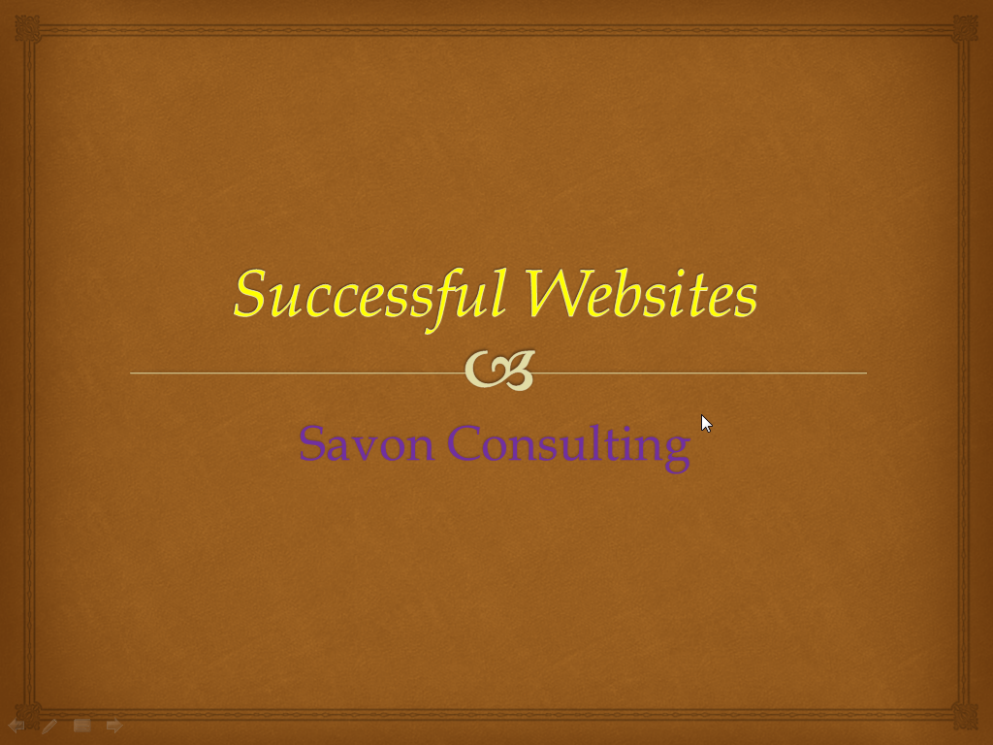

Figure PP1A – 2a

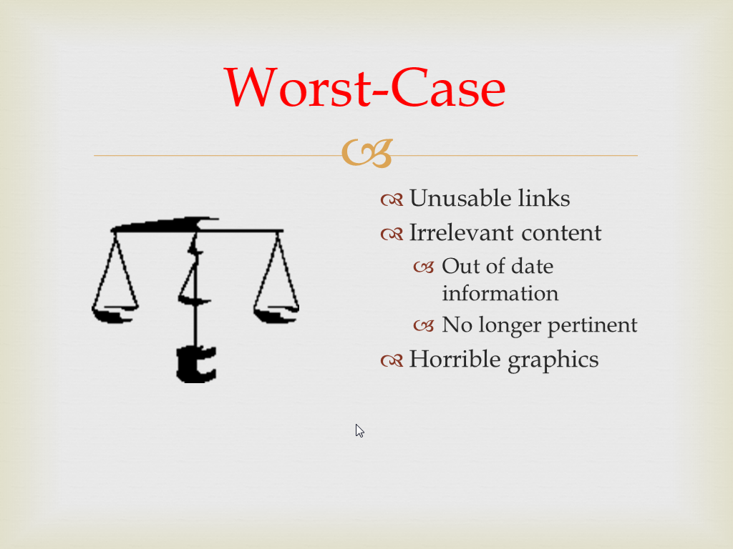

Figure PP1A – 2b

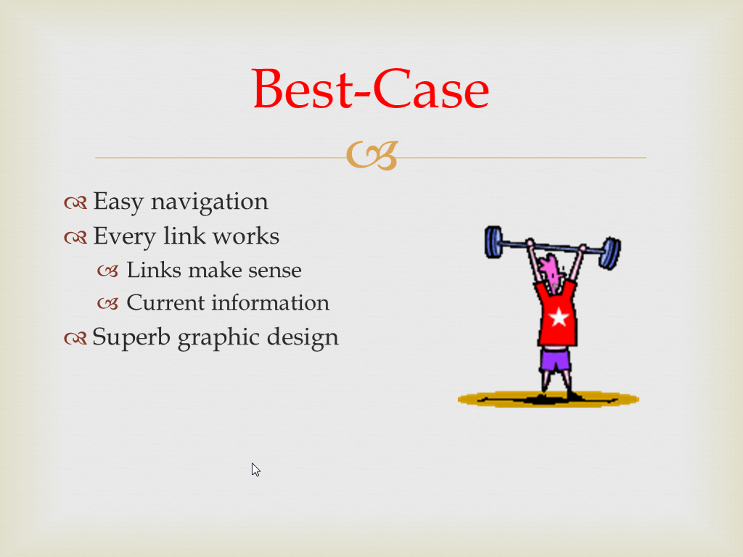

Figure PP1A – 2c

Figure PP1A – 2d

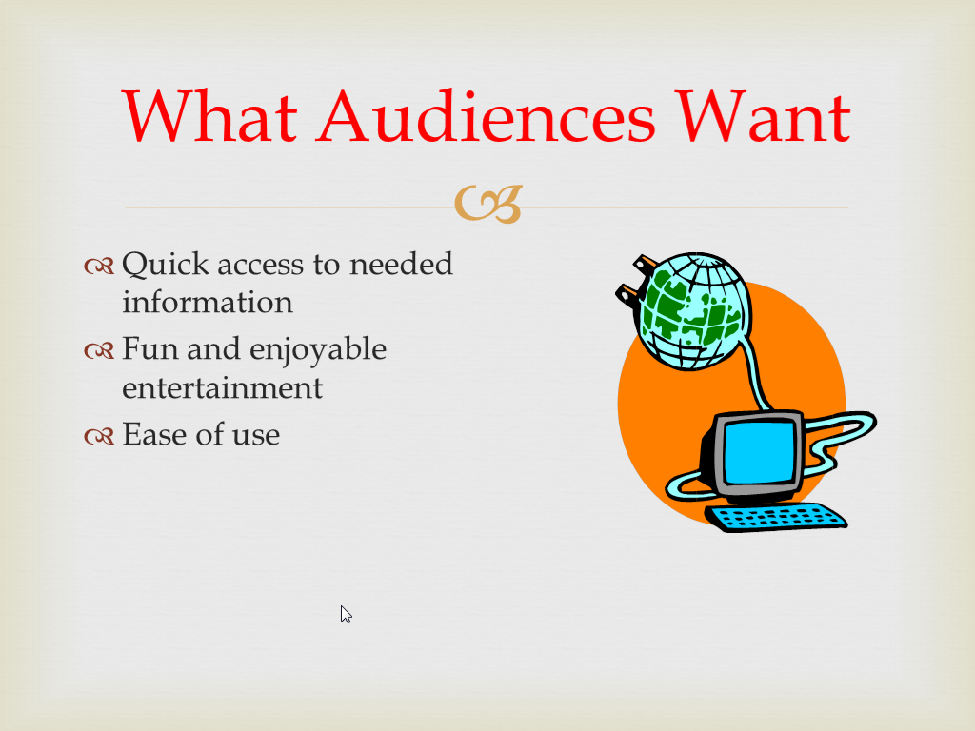

Figure PP1A – 2e

