Microsoft PowerPoint 2010 Chapter 1 – Lab Test B
Designing a Slide Presentation

Purpose: To demonstrate the ability to plan, design, and create a presentation.

Problem: You have been hired to develop a technology plan for a local chain of clinics. The plan covers the next two years and is designed to bring the chain up-to-speed with current technology. You are going to make a presentation at a meeting of the chain’s board of directors. (Note: Requested clip art files may be replaced with substitutes.)

Instructions: Perform the following tasks.

1. Create a new presentation using the Aspect document theme.
2. Using the typed notes illustrated in Figure PP1B-1, create the title slide shown in Figure PP1B-2a. Italicize the title, and increase the font size to 40 point. Change the font size of the of the subtitle text to .32 point. Change the font color of the title text to Red (second color in the Standard Colors row) and of the subtitle text to green (fifth color in the Standard Colors row).
3. Change the font color of the titles for Slides 2 – 5 to Green (fifth color in the Standard Colors row).
4. Using the typed notes in Figure PP1B-1, create the four text slides with bulleted lists shown in Figures PP1B-2b through PP1B-2e. Change the color of the title text on all slides to Green.
5. Choose the following layouts for the slides in the presentation.
a. Slide 1 – Title Slide
b. Slides 2, 4, and 5 – Title and Content
c. Slide 3 – Two Content – Make sure that the bulleted items are on each content side. This presentation is using the Aspect theme, so the two content slide will look different than that of other themes.
6. Add the clip art shown in Figures PP1B-2b through PP1B-2e from the Microsoft Clip Organizer. Adjust the clip sizes when necessary.
7. Apply the Honeycomb transition in the Exciting category to all slides. Change the duration to 4.25 seconds.
8. Drag the scroll box to display Slide 1. Click the Slide Show button to start Slide Show view. Then click to display each slide. Change the document properties, as specified by your instructor. Save the presentation using the file name, PowerPoint – Chapter 1 – Lab Test B.
9. Submit the revised document in the format specified by your instructor.

- More-Moni Clinics, Inc.
  - Beyond 2014
- More-Moni Clinics, Inc.
  - Health care information systems
  - Goals for the year 2012
  - Five-year technology plan
- Main Area of Focus
  - Overall infrastructure Communications
    - Training and learning
  - Integration
    - Labs, medical records, and workstations
    - Administrative and doctor’s offices
- Communications
  - Revamp entire telephone system
    - Digital Voice Paging
    - Digital Call Forwarding
- Training and Learning
  - Computerized classrooms
  - Interactive classrooms (online video and audio)
    - Connect to other clinics via the Internet
    - Connect to local colleges via the Internet

Figure PP1B – 1

Figure PP1B – 2a

Figure PP1B – 2b

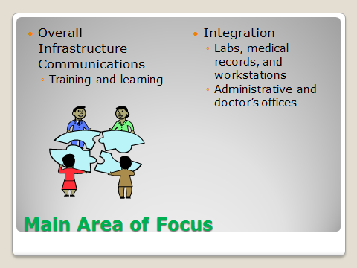

Figure PP1B – 2c

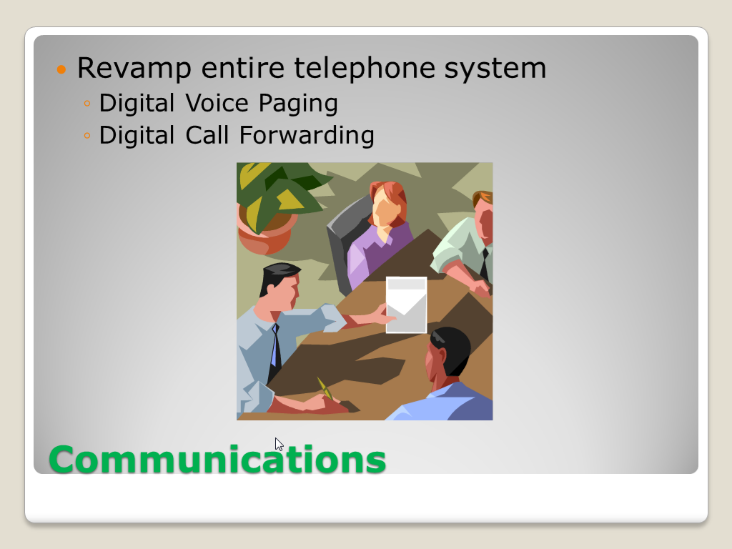

Figure PP1B – 2d

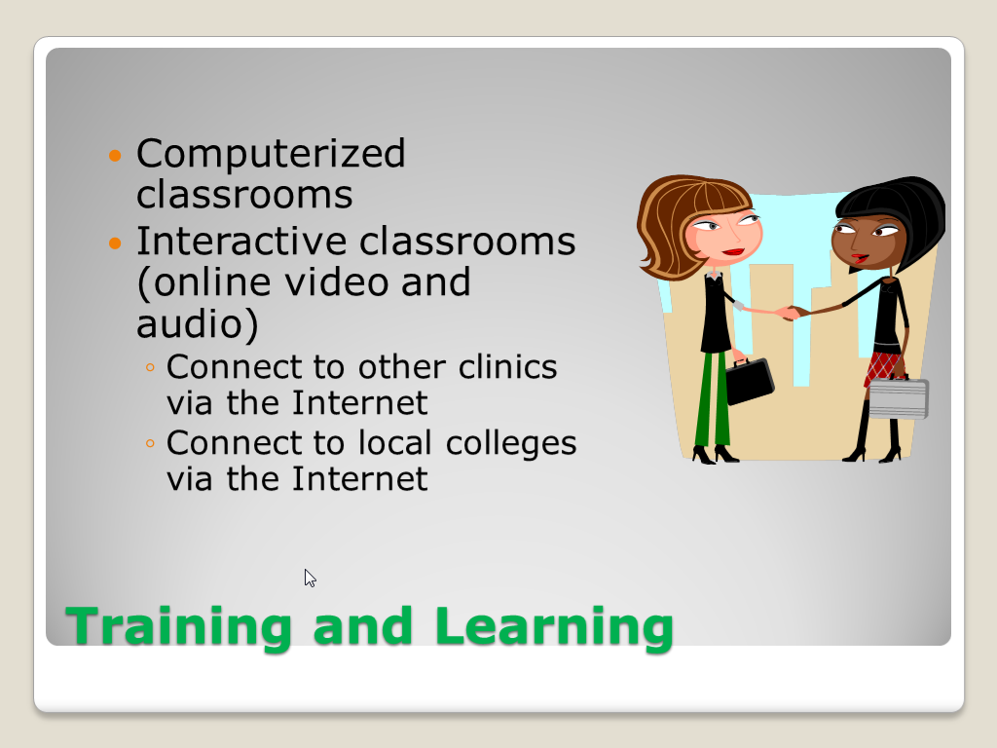

Figure PP1B – 2e

