Microsoft Word 2010 Chapter 1 - Lab Test B
Creating a Flyer with Two Pictures

Purpose: To demonstrate your ability to create a flyer by formatting text, importing and resizing images, spell checking, saving, and printing.

Problem: Your cats have recently had kittens. You want to give them out to good homes and so have decided to make a flyer with some pictures of the kittens on it for people to see.

Instructions: Download the data files for use in creating the flyer from a location provided by your instructor. Use the guidelines listed below to enter the text for the flyer as shown in Figure W1B-1. You are to format the flyer by making the changes listed below so it appears as shown in Figure W1B-2.

Perform the following tasks:
1. Start Word. Type the flyer text, unformatted. If Word flags any misspelled words as you type, check their spelling and correct them.
2. Save the document using the file name, Word Chapter 1 – Lab Test B.
3. Change the theme colors to the Elemental color scheme.
4. Center the headline, the line that says Kitty Caretaker Specs, and the signature line.
5. Change the font size of the headline to 36 point and the font to Comic Sans MS, or a similar font. Shade the headline paragraph Blue-Gray, Accent 4, Lighter 60%. Apply the text effect called Fill – Gray – 50%, Accent 6, Gradient-Outline – Accent 6.
6. Change the font size of body copy between the headline and the signature line to 22 point.
7. Change the font size of the signature line to 20 point and the font to Comic Sans MS. Bold the text in the signature line. Change the font color of the text in the signature line to Blue-Gray, Accent 4, Darker 25%. Using Change Case, change the text of the signature line to uppercase.
8. Bullet the three paragraphs of text above the signature line.
9. Italicize the word, fun.
10. Bold the word, good.
11. Double underline the text, March.
12. Shade the line that says Kitty Caretaker Specs to the Blue-Gray, Accent 4, Lighter 60% color. If the font color does not automatically change to a lighter color, change it to White, Background 1.
13. Change the zoom so that the entire page is visible in the document window.
14. Insert the two pictures centered on a blank line below the headline. The pictures are called Kitten 1 and Kitten 2 and are available in the data files for this lab test.
15. Resize the pictures so that it is approximately 2.3" × 3.07".
a. Apply the Bevel Rotated, Left - White picture style to the inserted pictures.
b. Apply the 3-D Rotation – Off Axis 2 Left picture effect to the first picture.
c. Apply the 3-D Rotation – Off Axis 1 Right picture effect to the second picture.
16. The entire flyer should fit on a single page. If it flows to two pages, resize the pictures or decrease spacing before and after paragraphs until the entire flyer text fits on a single page.
17. Add the page border shown in Figure W1B-2.
18. Change the document properties, including keywords, as specified by your instructor. Save the flyer again with the same file name. Submit the document, shown in Figure W1B-2, in the format specified by your instructor.
Want a Kitten?

My adorabe cats have graced me with new bundles of joy! Woulld you like to welcome one into your house? I need to find homes for thekitens by March.
Kitty Caretaker Specs
A good home filled with love
Lots of open spaes to explore
Funn toys for playtime
Call me today – 555-3479

Want a Kitten?
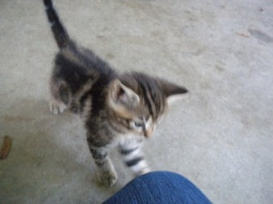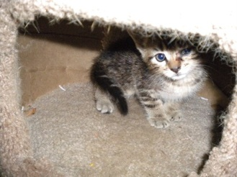
My adorable cats have graced me with new bundles of joy! Would you like to welcome one into your house? I need to find homes for the kittens by March.
Kitty Caretaker Specs
- A good home filled with love
- Lots of open spaces to explore
- Fun toys for playtime
CALL ME TODAY – 555-3479

